Understand Array Representation

How Arrays Are Represented in Memory:

* Arrays are stored contiguously in memory.
* Each element is accessed using an index, starting from 0.
* The address of any element can be found using: address = base_address + index * size_of_element

Advantages of Arrays:

* Fast access (O(1) time) to any element using an index.
* Memory-efficient for fixed-size data collections.
* Easy to implement for small, known-size datasets.

Analysis:

|  |  |  |
| --- | --- | --- |
| Operation | Time Complexity | Explanation |
| Add | O(1) | Adds at the end of the array |
| Search | O(n) | Linear search through the array |
| Traverse | O(n) | Visit each employee once |
| Delete | O(n) | Shifts elements after deletion |

Limitations of Arrays

* Fixed Size:
  + You must define the size at the start.
  + Cannot grow dynamically.
* Complex Deletion/Insertion:
  + Requires shifting elements, which is O(n).

Code:

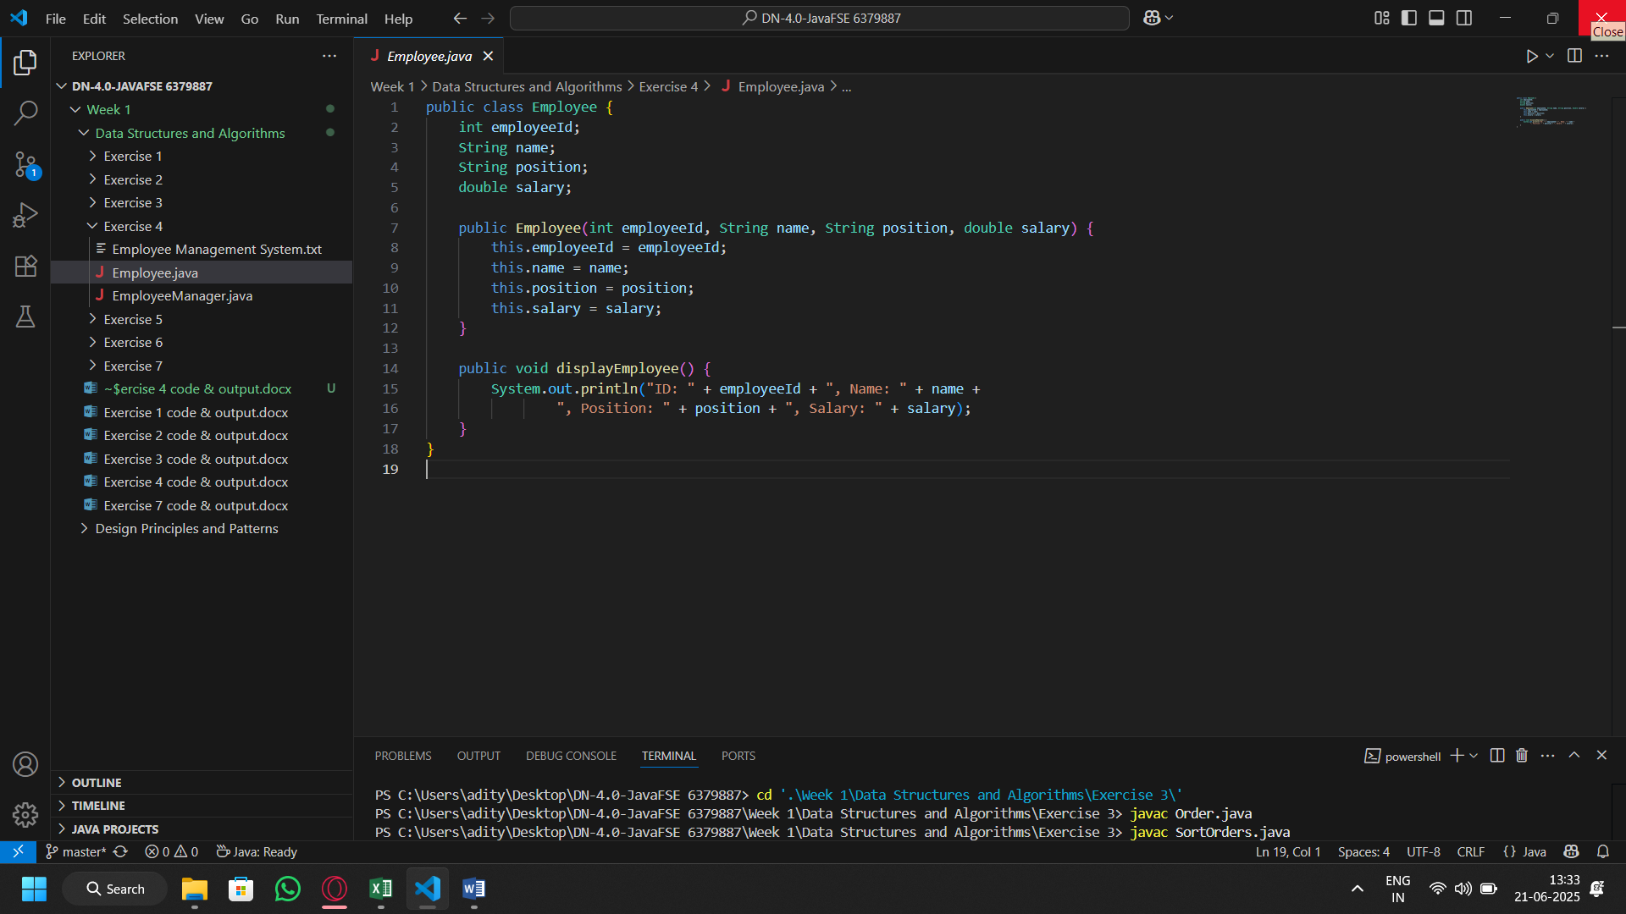Employee Class

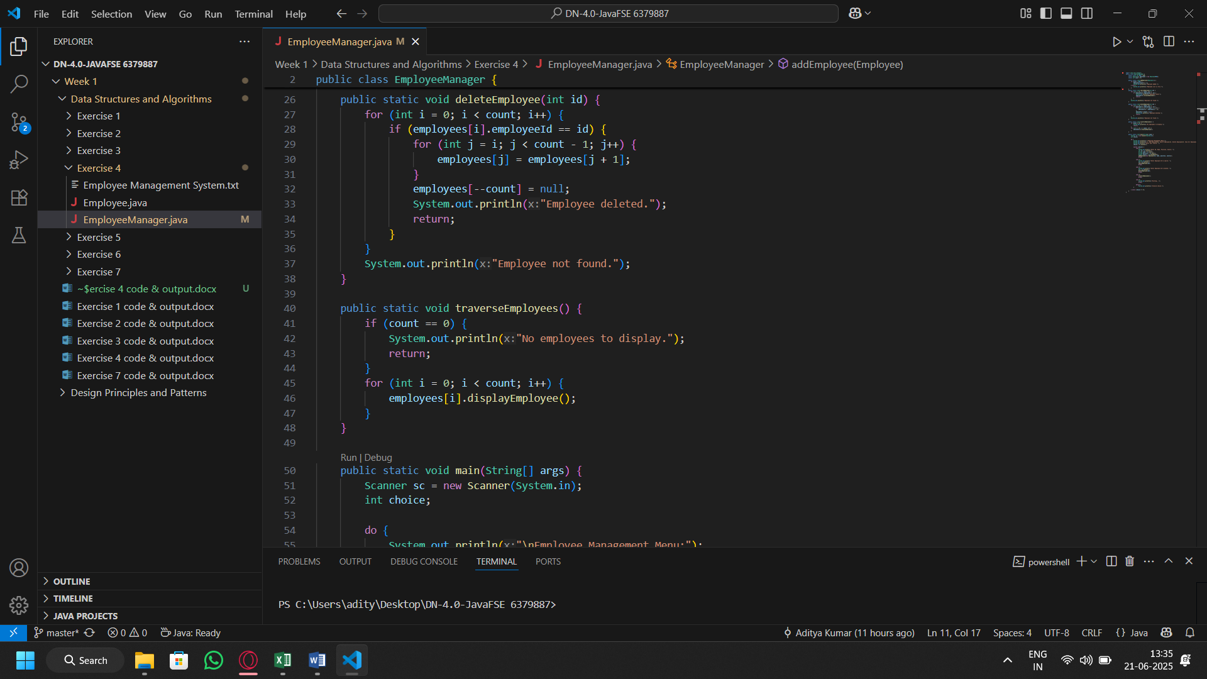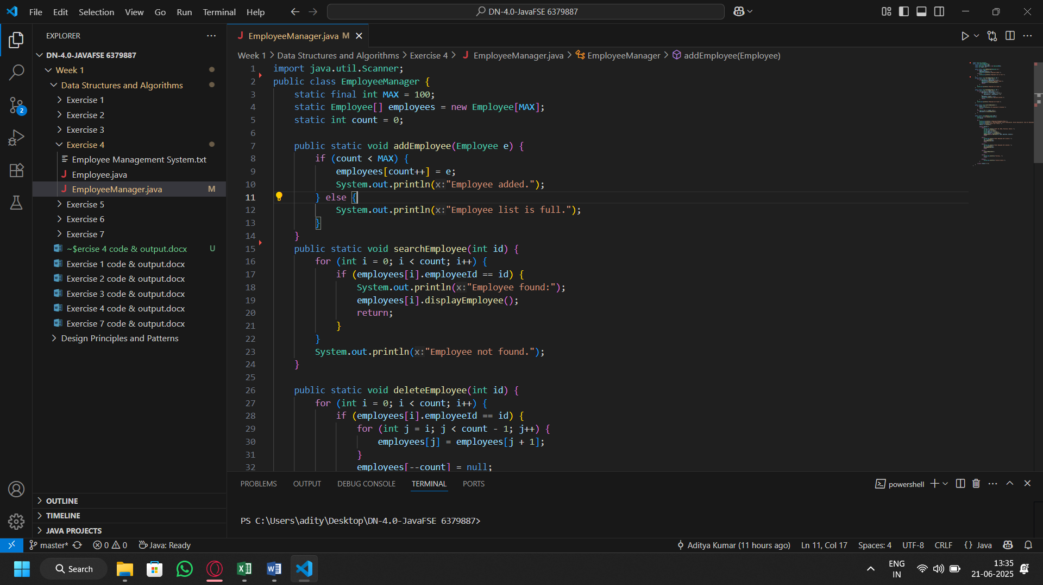Employee Manager Class

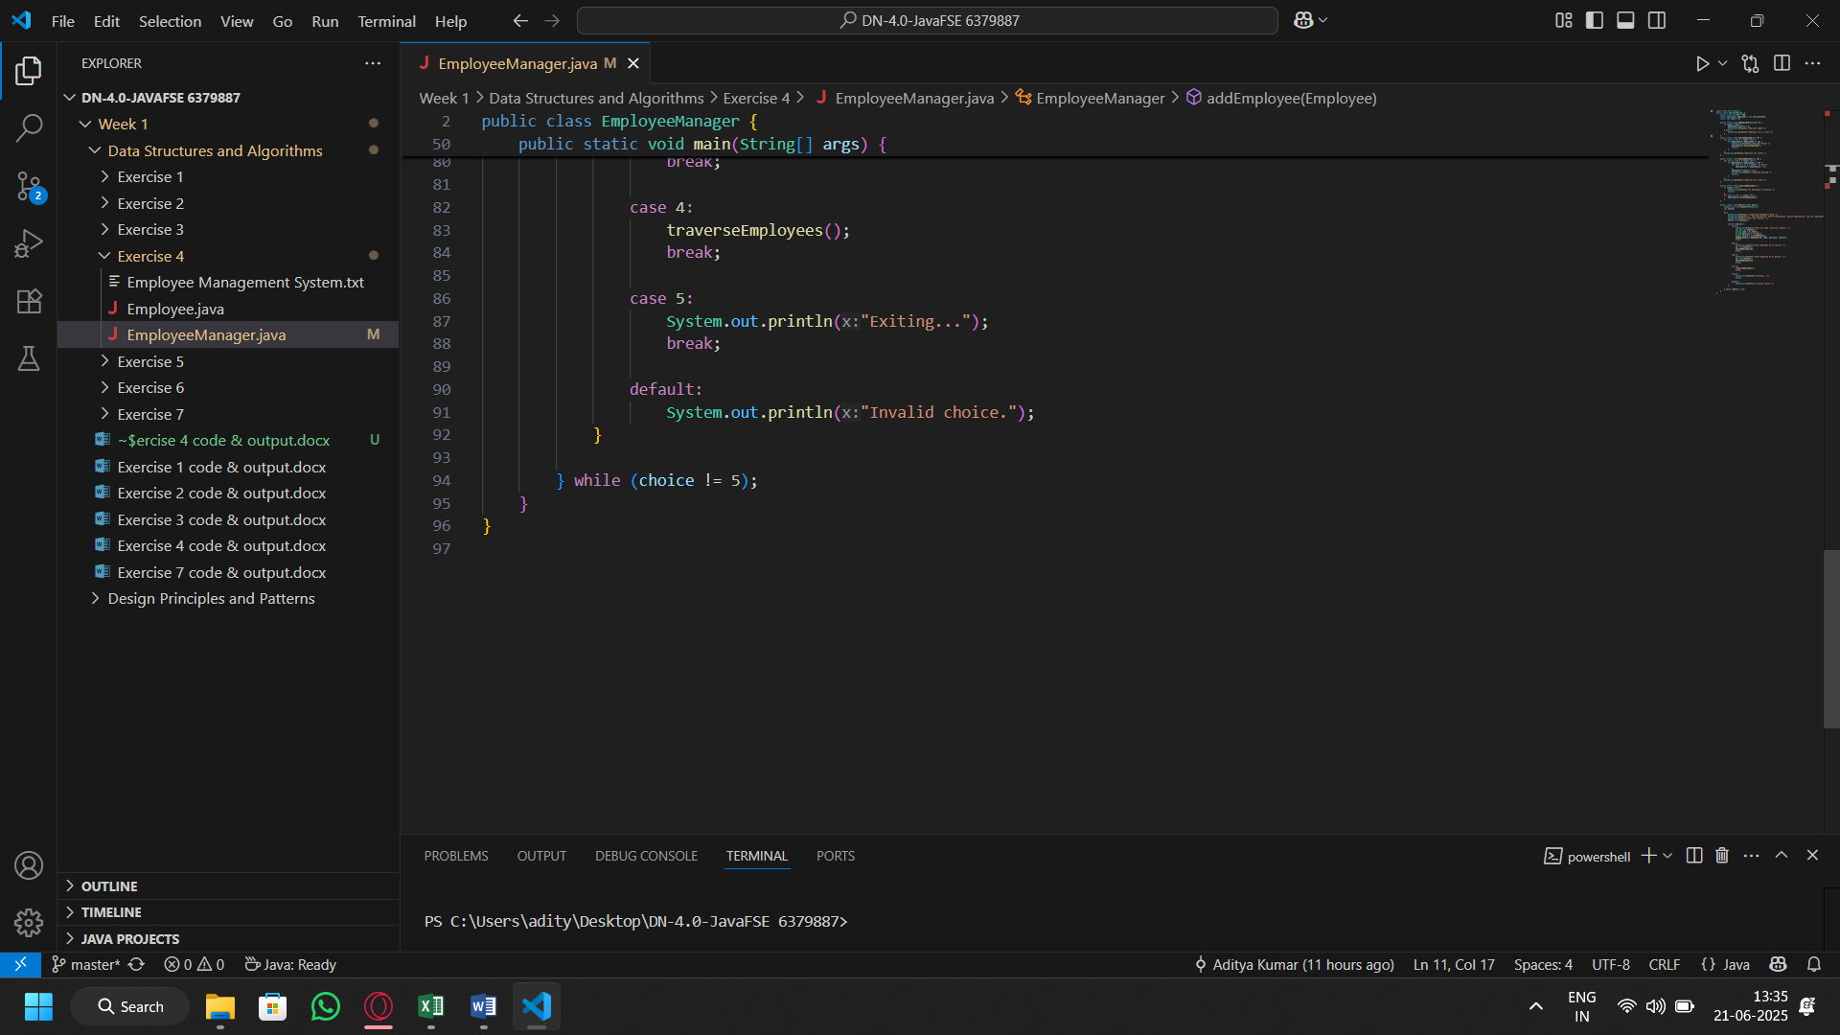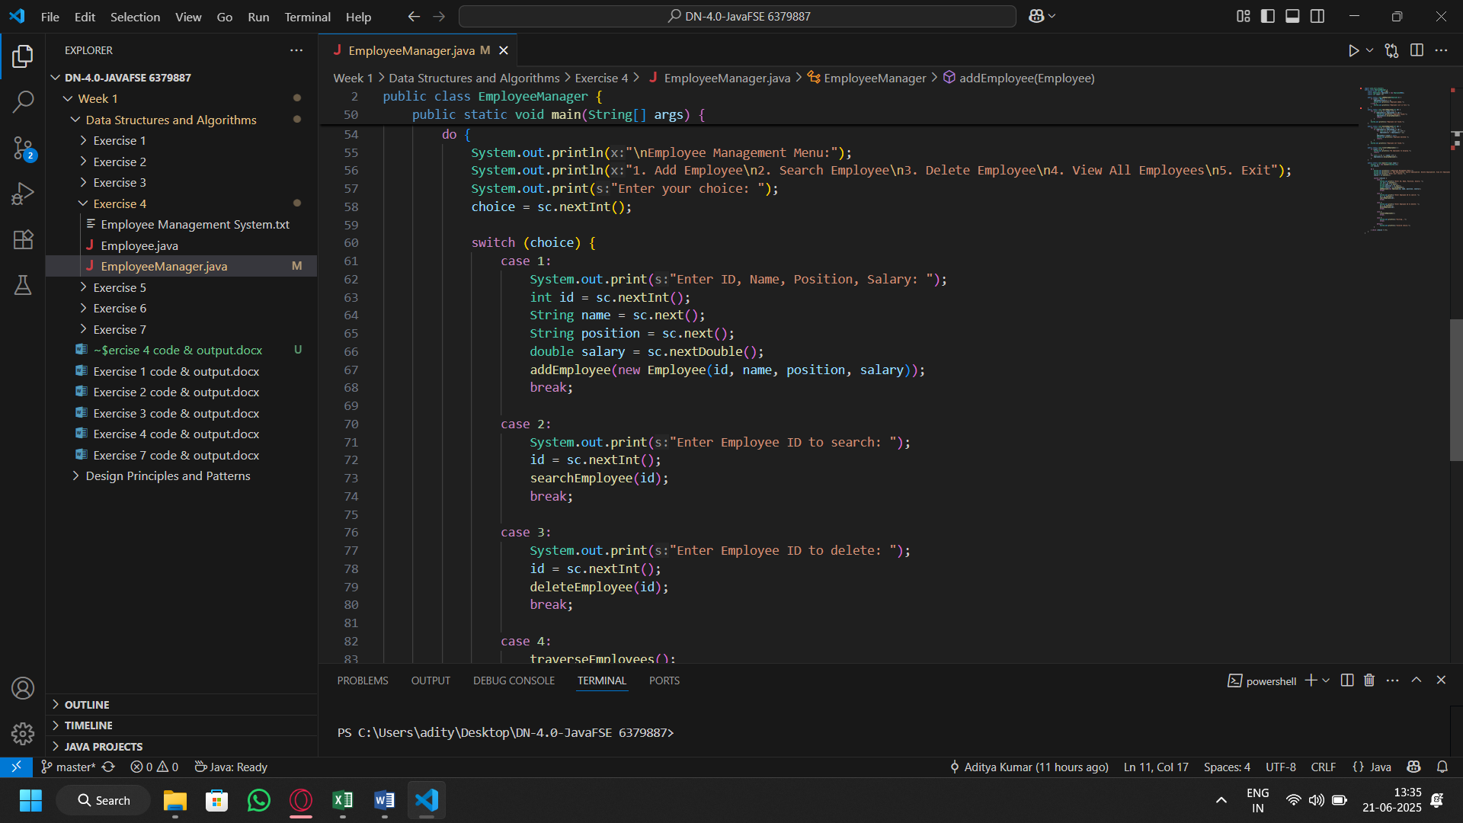

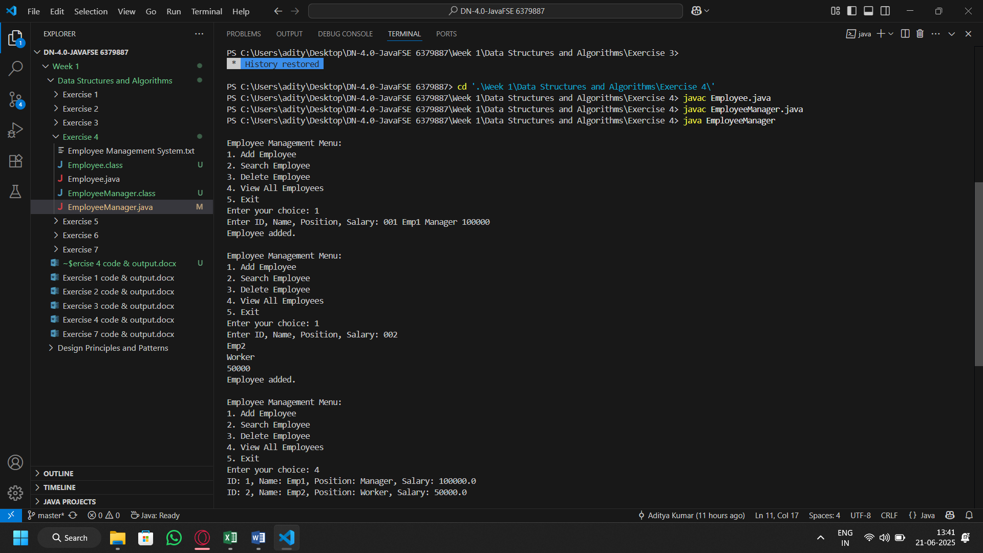Output: